**Payroll Activity Report**  
It does show anything else done to an employee’s record including an administrator approving a timesheet, a bank account change, or when OneTouch Payroll processes a transaction. Since there should be supporting approvals for each of these transactions from outside the payroll group, these transactions are easily verified by the reviewer.

This report is generated as a PDF file so the information cannot be manipulated after it has been created. Additionally, the report is run using the “execution date” rather than effective date so that changes made retroactively before the current pay period, or in the future, are not missed.

Part of the best practice process using this report as a control is to ensure contiguous “from / thru” dates are used from report to report. For example, in the report below, the From Date is 9/01/2012 and the Thru Date is 9/15/2012. The next report run should start on 9/16/2012 to keep the integrity of the control in place.

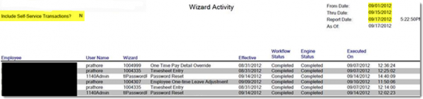

**Payroll Variance Report**

The Payroll Variance Report allows you to quickly see which employee’s payroll has changed from the previous payroll. The report lets the user set the variance amount to eliminate having to review very small changes that routinely occur from pay period to pay period. The reviewer can verify the specific approvals for any reported variances either in the electronic files or with the paper files in the office.

In addition to new and former employees, changes in hourly rates and number of hours worked in a period are shown with the detail required to verify the variance. This quick check safeguards both the employee and the company from costly mistakes.

